**Implementation of Mesh Topology**

**Step 1:**First, open the Cisco packet tracer desktop and select the devices given below:

| **S.NO** | **Device** | **Model name** |
| --- | --- | --- |
| **1.** | PC | PC |
| **2.** | Switch | PT-switch |

**IP addressing values to be given as shown in the table below:**

| **S.NO** | **Device** | **IPv4 Address** | **Subnet Mask** |
| --- | --- | --- | --- |
| **1.** | pc0 | 192.168.0.1 | 255.255.255.0 |
| **2.** | pc1 | 192.168.0.2 | 255.255.255.0 |
| **3.** | pc2 | 192.168.0.3 | 255.255.255.0 |
| **4.** | pc3 | 192.168.0.4 | 255.255.255.0 |

Then, create a network topology as shown below the image. Use an Automatic connecting cable to connect the devices with others.

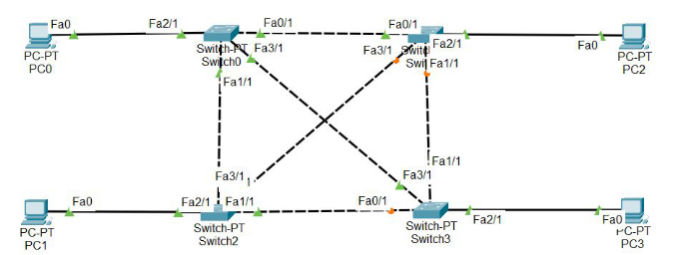

**Step 2:** Configure the PCs (hosts) with IPv4 address and Subnet Mask according to the IP addressing table given above.

* To assign an IP address in PC0, click on PC0.
* Then, go to desktop and then IP configuration and there you will IPv4 configuration.
* Fill IPv4 address and subnet mask.

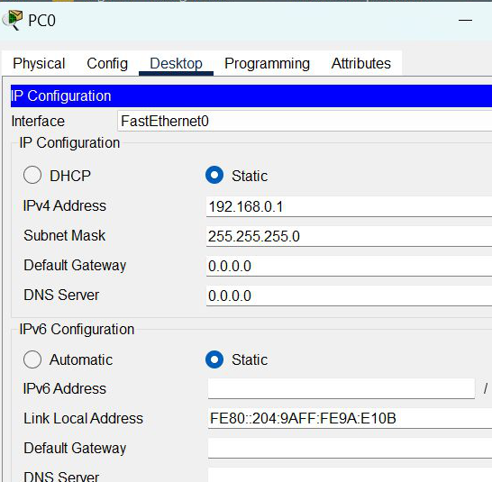

Assigning IP address using the ipconfig command.

Also, we can also assign an IP address with the help of a command.

Go to the command terminal of the PC.

Then, type ipconfig <IPv4 address><subnet mask><default gateway>(if needed)

ipconfig 192.168.0.1 255.255.255.0

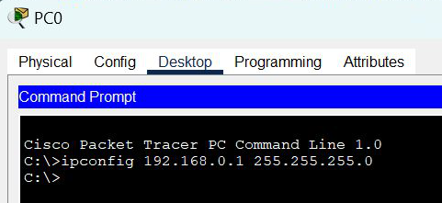

Repeat the same procedure with other PCs to configure them thoroughly.

**Step 3: Verify the connection by pinging the IP address of any host in PC0.**

Use the ping command to verify the connection.

We will check if we are getting any replies or not.

If we get replies from a targeted node on both PCs.

Then we can say the connection is verified.

